# **Project Report**

Disha Behere

Department of Systems and Computer Studies

[dishabehere@cmail.carleton.ca](mailto:dishabehere@cmail.carleton.ca)

1. **Introduction**

Inventory is one of the most valuable things a business owns. In many fields, like retail, food service, and manufacturing, not having enough inventory can hurt business. Inventory is not only a liability, but it can also be seen as a risk. It can be easy to steal, break, or go bad. Having a lot of stock can also cause sales to go down. No matter how big or small your business is, it is very important to have a good system for managing your inventory. It can help you keep track of all of your supplies and figure out how much they cost. Hence, I got the idea of making an inventory management system.

1. **Libraries Used**

In this section I will discuss the libraries used in my project.

**2.1 sqlite3**

A lightweight disk - based database called SQLite is a C library that enables access to the database using an alternate form of the SQL query language without the need for a separate server process. Some programs provide internal data storage using SQLite. Additionally, you might use SQLite to create an application prototype before moving the code to a more robust database like PostgreSQL or Oracle. Gerhard Häring is credited for creating the sqlite3 module. There is a SQL interface available.

**2.2 TKinter**

The Python binding for the Tk Graphical User Interface toolkit is called Tkinter. It is most widely used module in python for making Graphical User Interface. Tk interface is where the word Tkinter originates. Steen Lumholt and Guido van Rossum wrote Tkinter, which Fredrik Lundh subsequently updated.

**2.3 tkinter.messagebox**

The tkinter.messsagebox module offers many convenient methods for frequently used settings in addition to a template base class. Depending on the user’s choice, the modal message boxes will return a subset of(true, False, OK, None, Yes, No).

**2.4 tkinter.ttk**

Access to the Tk themed widget collection, introduced in the Tk 8.5, is provided through the tkinter.ttk module. It also offers window transparency and X11 anti-aliased font rendering, among other advantages.

**2.5 tkcalender**

The calendar and DateEntry widgets for tkinter are provided by the Python programme tkcalender. The DateEntry widget resembles a combo box, but instead of a list in the drop-down menu for choosing a date, it has a calendar. 1

**2.6 Pillow**

Alex Clark and contributors of Pillow have created a user-friendly version of the PIL fork called "Pillow" PIL stands for the Python Imaging Library, which was developed by Fredrik Lundh and a number of other contributors.

**2.7 Time**

This module provides various functions to manipulate time values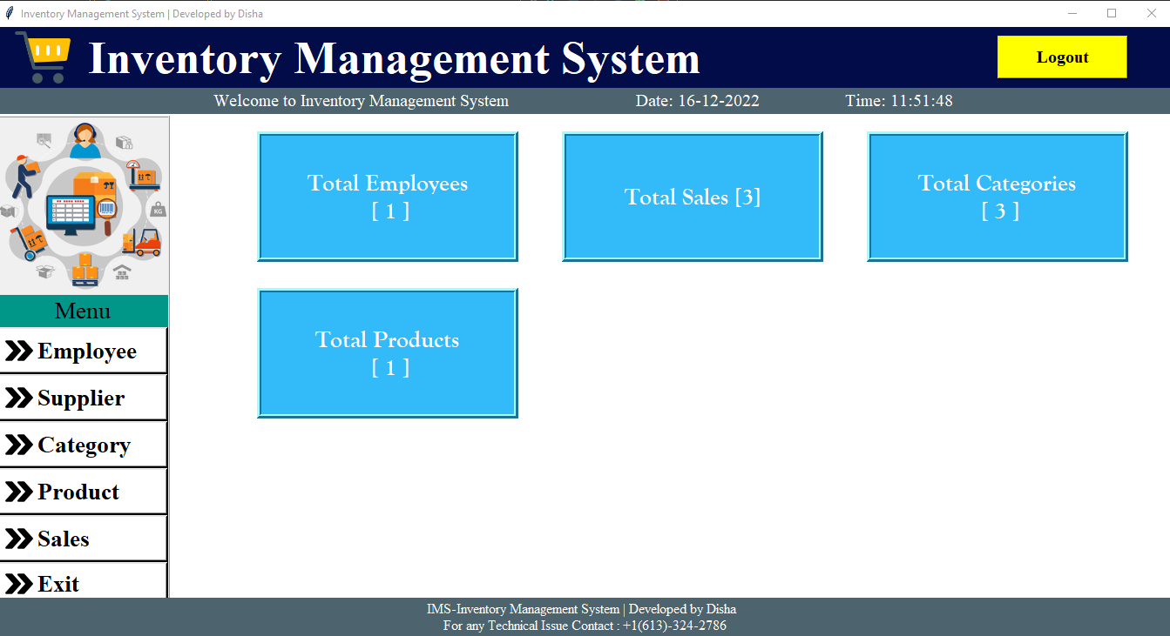.

**3 Project**

I have used tkinter in order to make the GUI interface of the application which will help the user to navigate between the functions of the applications. I have also used pillow module to implement images in the GUI. The main database which is used to store details of spending is used by the sqlite3 which is very good for beginners to use the database who do not have any idea about the Oracle or any other database which uses sql. As soon as the application is launched the user will we able to see the five-options named (Employee, Supplier, Category, Product and Sales).

**3.1 Employee**

The below image shows the page that pops up when we click on the employee button on dashboard. There are various fields on this page loke id, name gender contact etc.

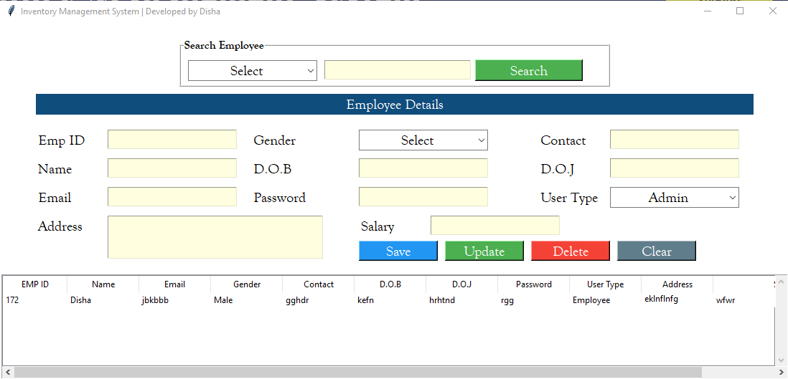

**3.2 Supplier**

The following page pops up when we click on the supplier button on dashboard. Here, user can add various details for the suppliers.

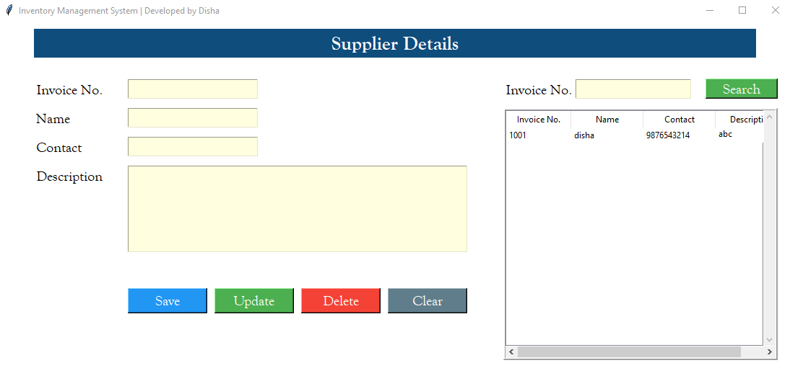

**3.3 Category**

Following image shows the Product Category page which can be accessed by clicking on categories button on dashboard.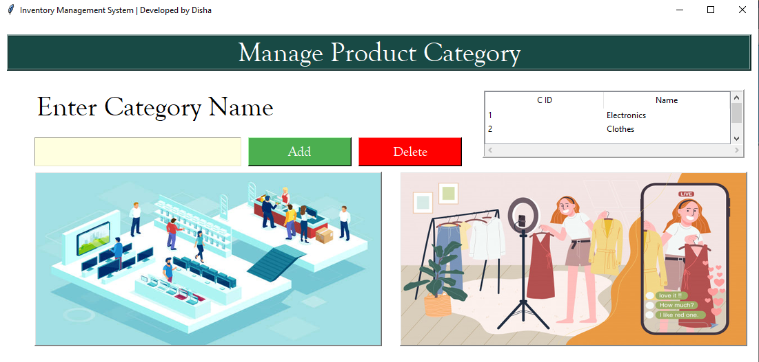

**3.4 Product**

The product page enables the user to add and manage different products.

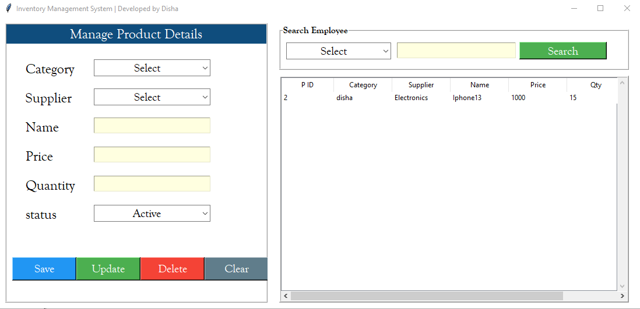

**3.5 Sales**

The sales windows show the invoices that are currently present in the system as text files.

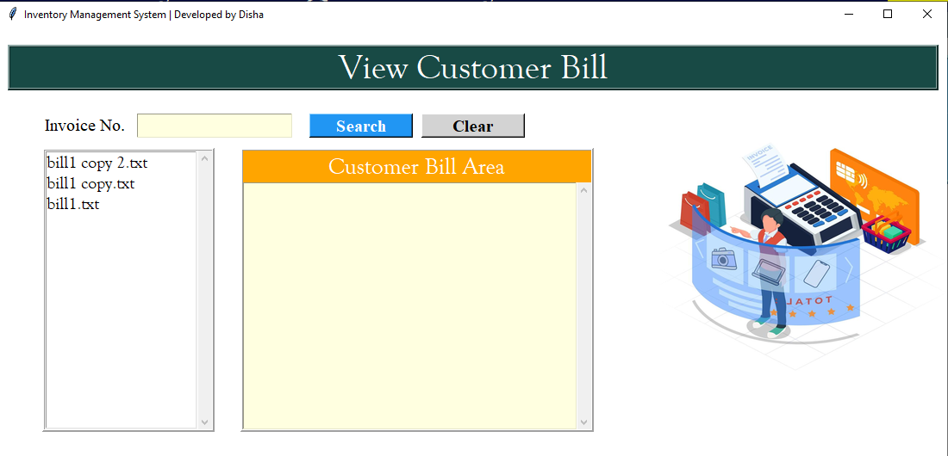

**4 Reflection**

In this section, I'll discuss how the knowledge I gained from the course aided in the creation of this project:

The project worked well because of the fundamentals of Python that were taught in class. The weekly assignments proved to be very helpful as everything I learned in class was subsequently required in some way or another for the assignments and the quizzes. However, simple python coding cannot produce any such massive projects.

The "PILLOW" package, which I had learned about in the course, enabled me add graphics into my project, enhancing the user experience of the constructed User Interface. First and foremost, returning to an in-person class after a two-year absence—rather than taking it virtually or through Zoom sessions—inspired me to undertake this initiative. As a result of everyone in the class participating and putting their best effort forward, the classroom developed a competitive atmosphere. The course was excellently designed so that someone unfamiliar with coding environments could learn new skills and start a career in this field, and it steadily increased the difficulty of the assignments.

**5 Future Scope**

* **Data Storage in the Cloud:** By storing data in the cloud, a person may access all of their financial information from any device because everything is kept there, which also benefits them because it frees up memory on the device they are using.
* **Unique Login ID:** By creating a unique login ID for employees and suppliers the app can be easily accessed by everyone.